A509-AM,C-Costa Rica-Vessel Leg Fragment-300-800 CE

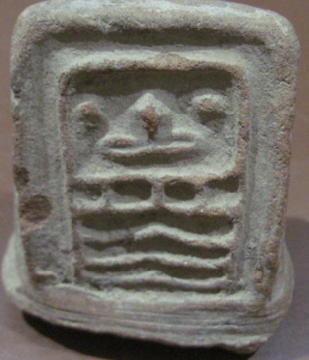 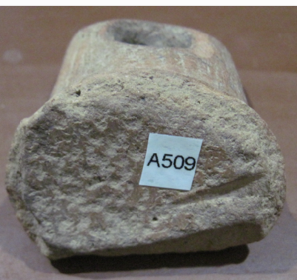

Costa Rica-Vessel Leg Fragment-300-800 CE

Case No.: 14

**Accession No.**

**Formal Label:** Costa Rica-Vessel Leg Fragment-300-800 CE

**Display Description:**

Pre-Columbian Terracotta Vessel leg fragment with traditional head

**LC Classification:**

**Date or Time Horizon:**

**Geographical Area:**

**Map:**

**GPS coordinates:**

**Cultural Affiliation:**

**Media:**

**Dimensions:** 9.1cm x 7.8cm x 5.9cm some trace of original paint

**Weight:**

**Condition:**

**Provenance:** from a large Tucson Arizona Professors Collection  
 collected in the 1950"s **CAA-16**

**Discussion:**

**References:**